**Software Requirements Specification (SRS)**

**1. Introduction**

1.1 Purpose

The purpose of the Home Glam website is to offer on-demand beauty services specifically designed for women, delivering professional treatments like facials, haircuts, bridal makeup, and more, directly to their homes. By eliminating the need for women to visit traditional parlours, Home Glam aims to provide a convenient, comfortable, and personalized beauty experience. This platform allows users to easily book appointments with skilled beauty professionals, ensuring a high standard of service quality while maintaining a seamless and user-friendly interface. This document outlines the functional and non-functional requirements essential for the development of the Home Glam platform.

1.2 Document Conventions

**Abbreviations:**

* **Home Glam:** The name of the beauty service platform.
* **UI:** User Interface
* **SRS:** Software Requirements Specification
* **JWT:** JSON Web Token used for secure user authentication.
* **HTML:** HyperText Markup Language used for structuring web content.
* **CSS:** Cascading Style Sheets used for styling the website.
* **PHP:** Hypertext Preprocessor used for backend scripting and handling business logic.
* **MySQL:** Relational database management system used for storing customer, booking, and service data.
* **API:** Application Programming Interface used for communication between the frontend and backend of the platform.
* **Admin:** Users with administrative privileges, responsible for managing services, users, bookings, and reviews.

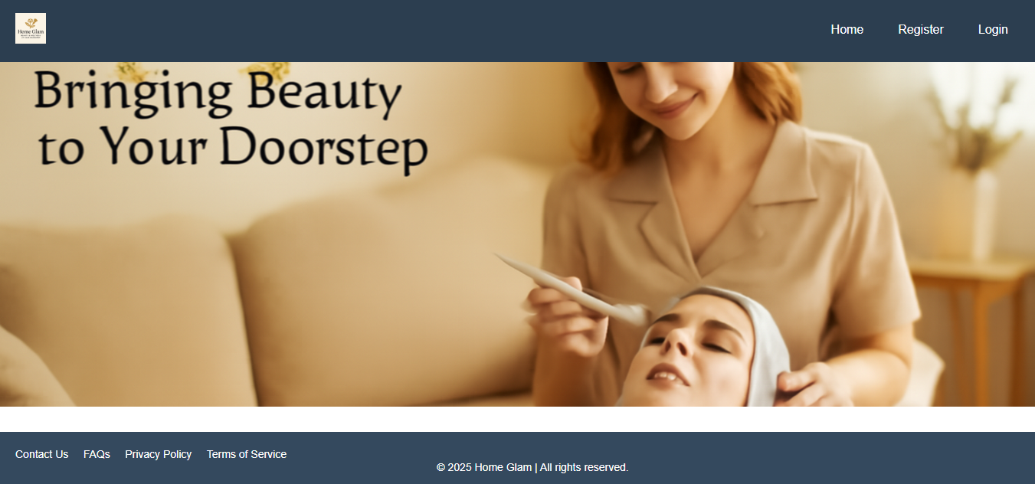

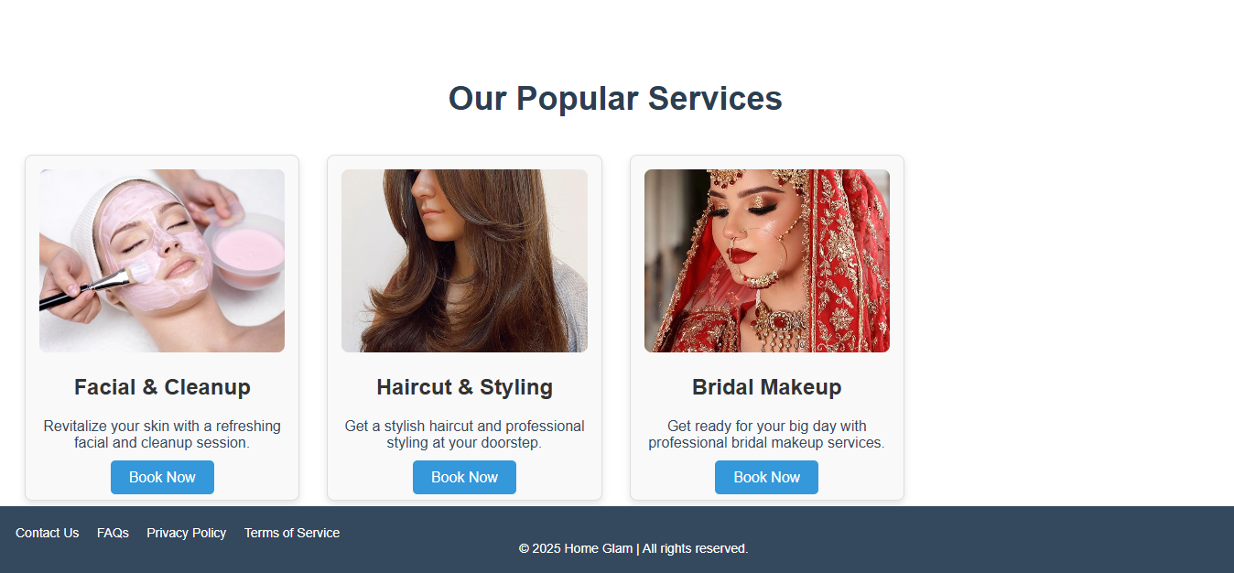

**Standards:**

* The document follows IEEE 830-1998 standards for Software Requirements Specification (SRS).
* **Design Standards:** The platform uses a mobile-first approach with responsive web design to ensure optimal viewing on mobile and desktop devices.
* **Security Standards:** User authentication follows secure practices using JWT, and the platform ensures encrypted transmission of data via HTTPS.
* **Compliance:** The platform follows relevant data protection regulations such as GDPR, ensuring user data privacy and security.
* **UI Design:** Tailwind CSS is used for building a responsive and user-friendly interface.
* **Database Design:** The platform uses MySQL for storing and managing user information, bookings, services, and reviews.

ent. 1.3 Intended Audience and Reading Suggestions

The intended audience for this document is primarily **home parlour owners** and **customers** of the Homeglam website. The website provides a platform for parlour owners to manage their services, offers, and customer interactions, while allowing customers to search for parlours, make bookings, and leave reviews.

* **For Parlour Owners**: Navigate the platform to manage services, create special offers (combos), view and respond to customer messages, and track bookings.
* **For Customers**: Explore parlours, read reviews, book appointments, and manage favorites.

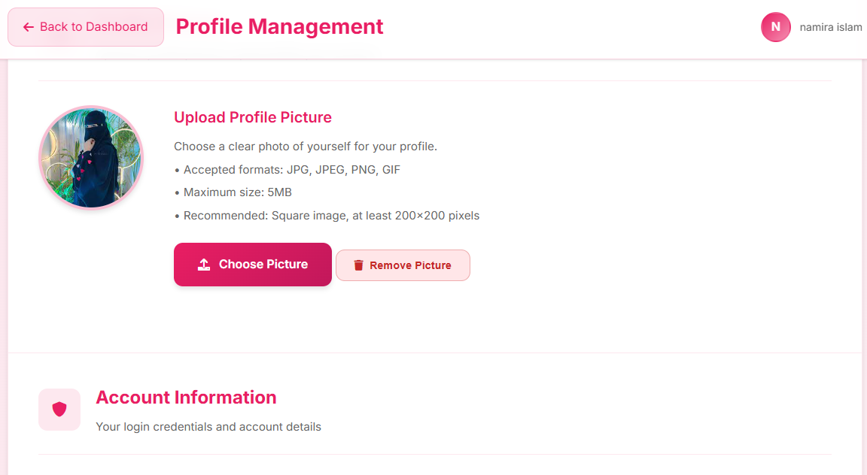

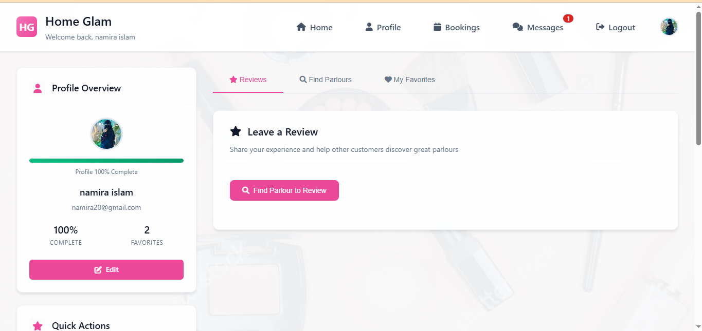

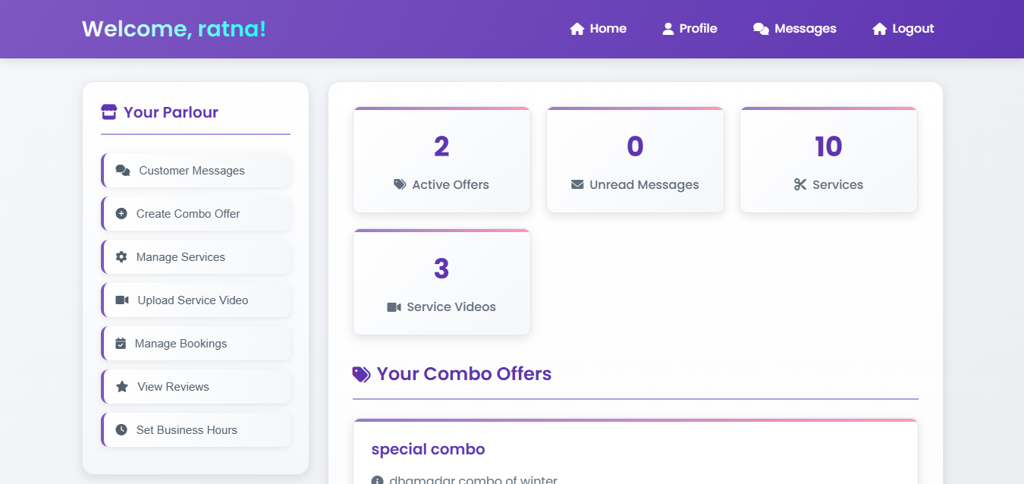

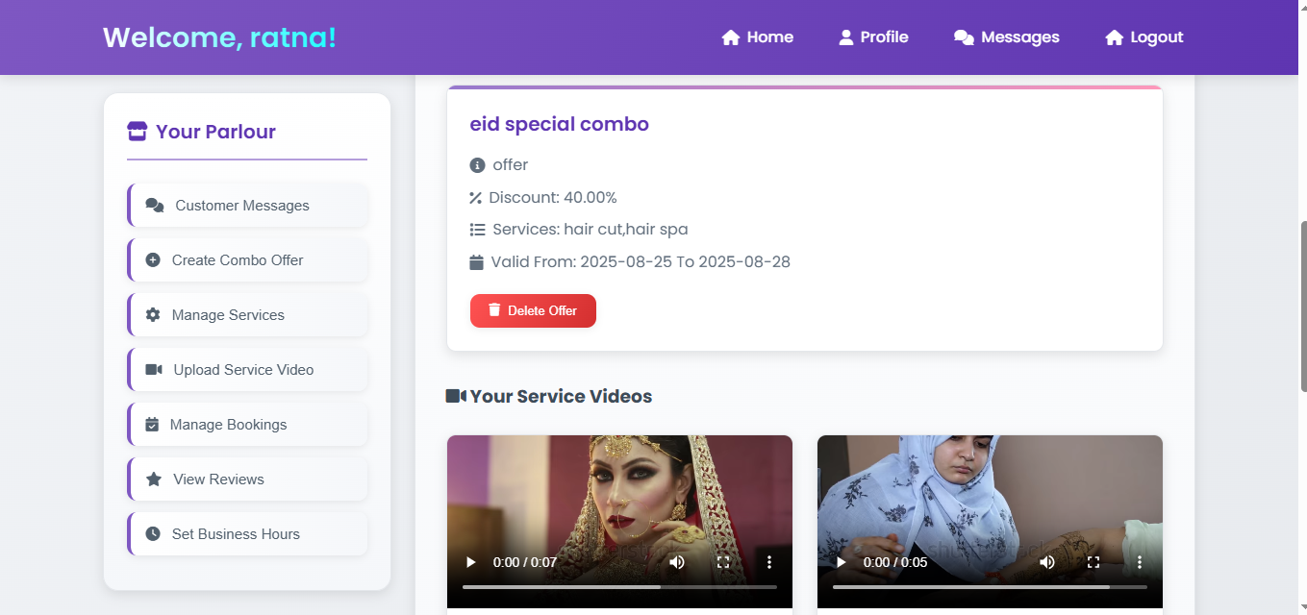

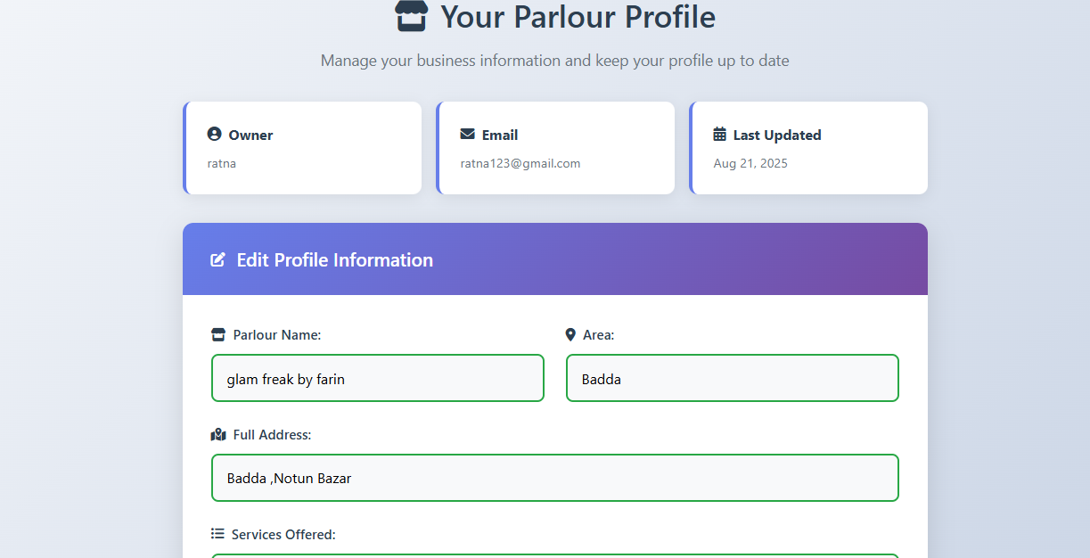

1.4 Project Scope

Homeglam is an online platform for **home parlour services for women in Dhaka**, connecting parlour owners with customers. Its main objectives and functions are:

* **User Profiles**: Parlour owners and customers have personalized dashboards. Parlour owners manage their services, customer bookings, and offers, while customers manage their profile, view their bookings, and provide reviews.
* **Services and Offers**: Parlour owners can list their services, set pricing, and create combo offers with discounts. Customers can view, book, and enjoy these offers.

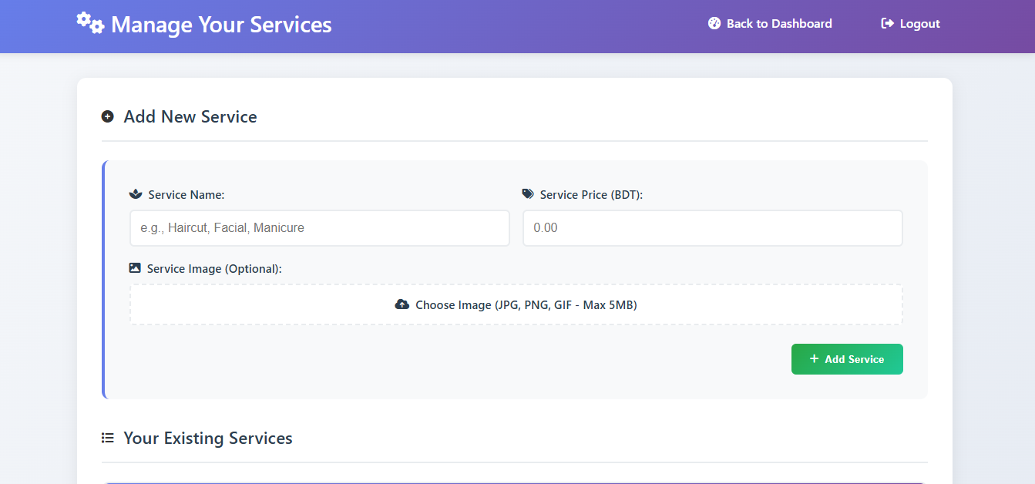

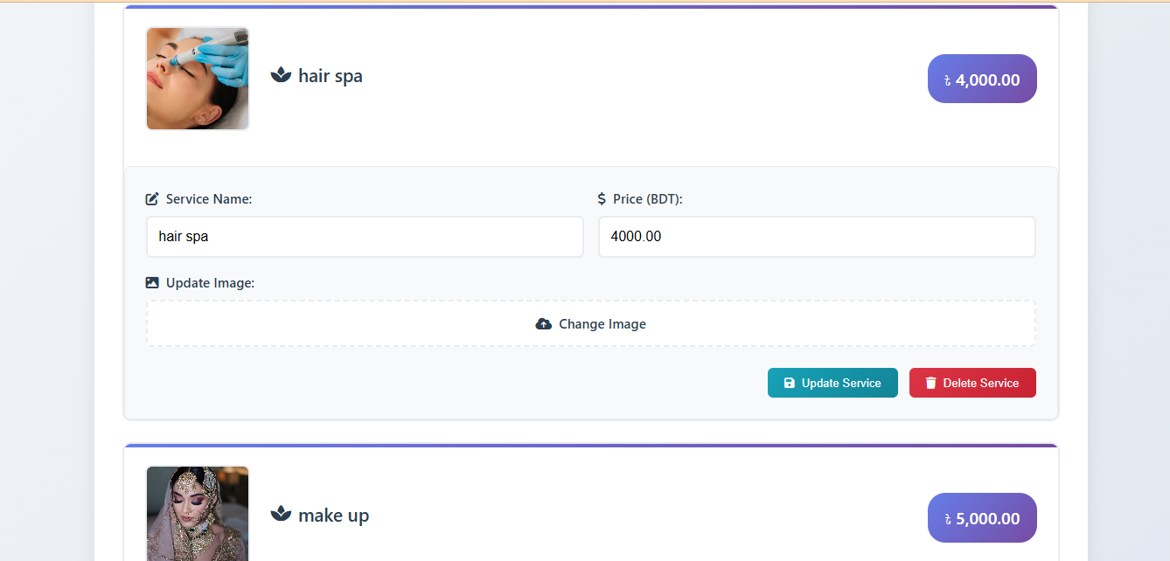

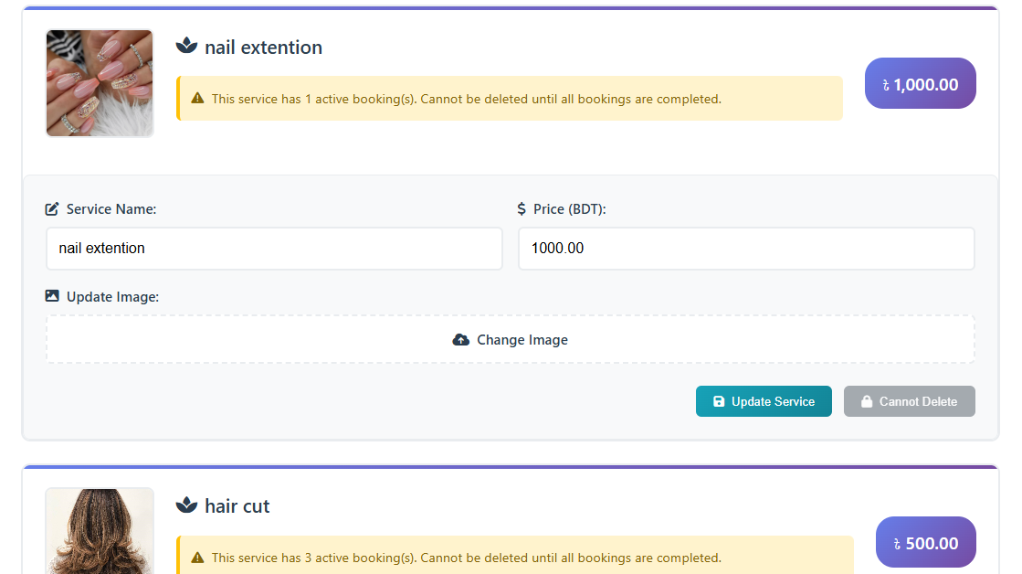

* **Booking System**: A system for customers to book services directly from parlours. Parlour owners can manage and track these bookings.

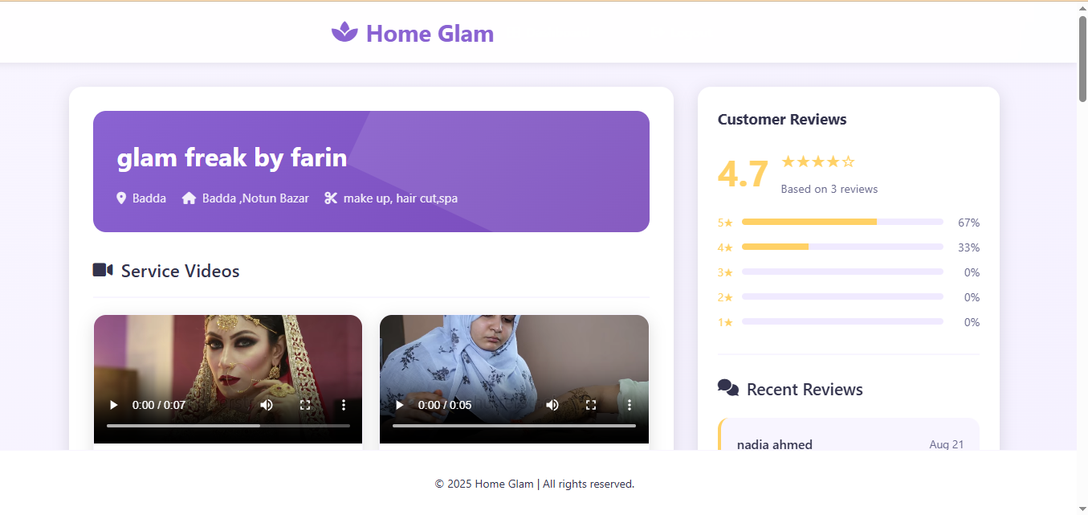

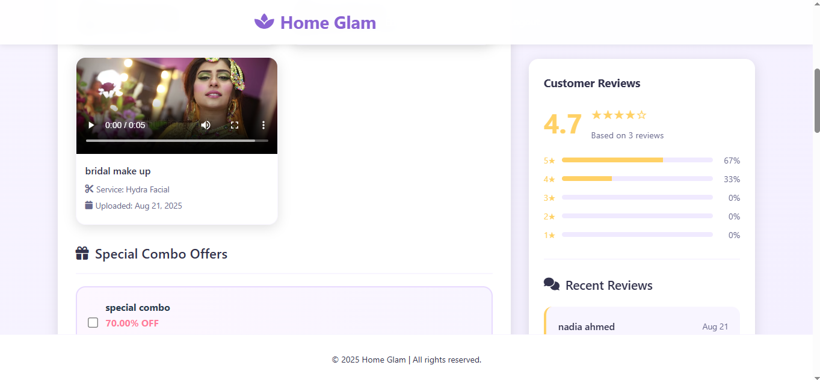

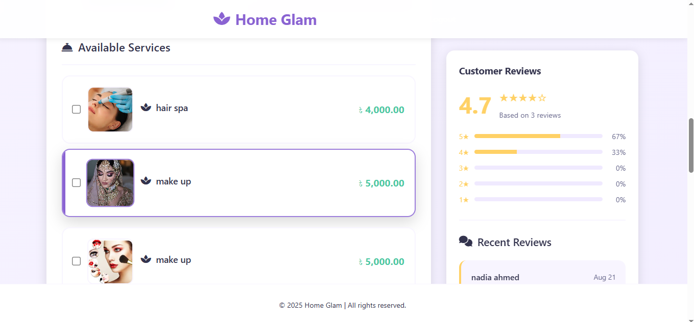

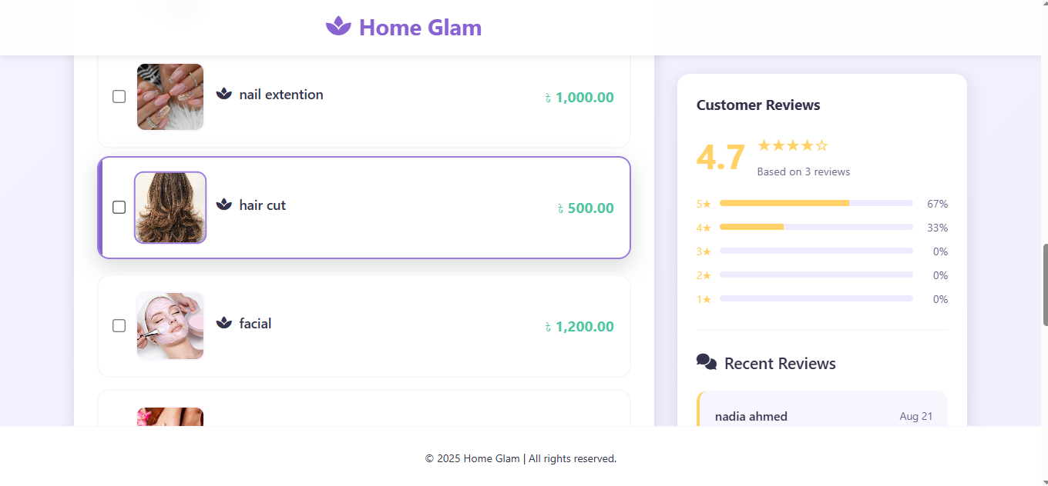

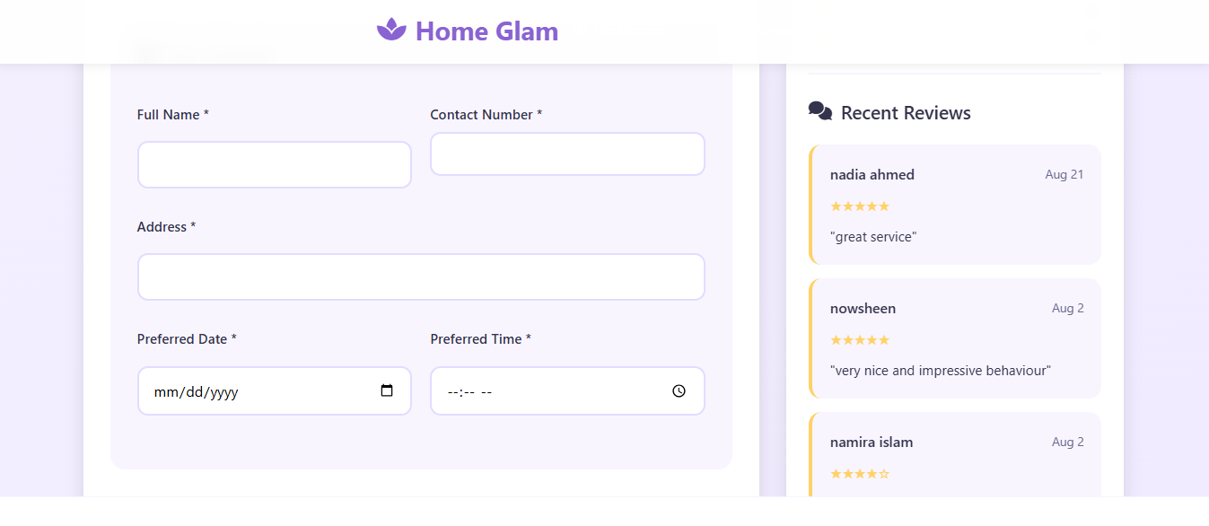

* **Customer Feedback**: Customers can leave reviews on the parlours they visit, helping others make informed decisions.

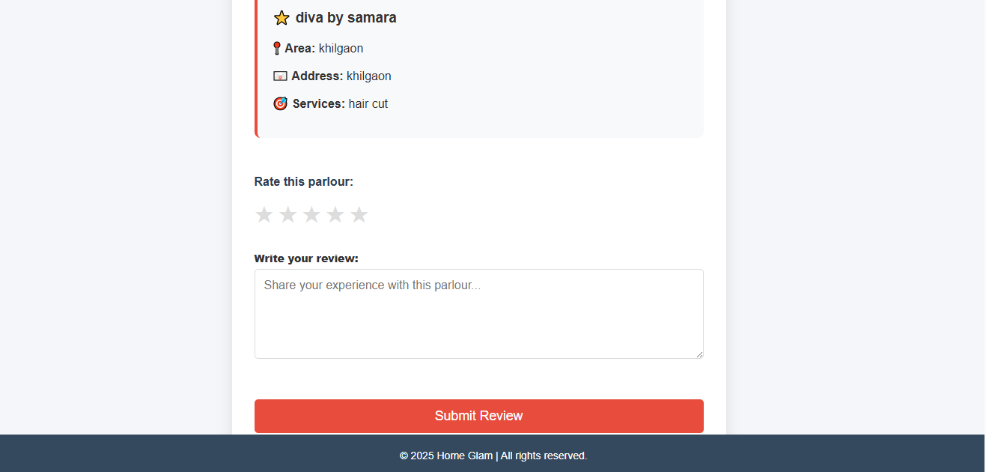

* **Messaging System**: A messaging feature allows parlour owners and customers to communicate directly, addressing inquiries and feedback.

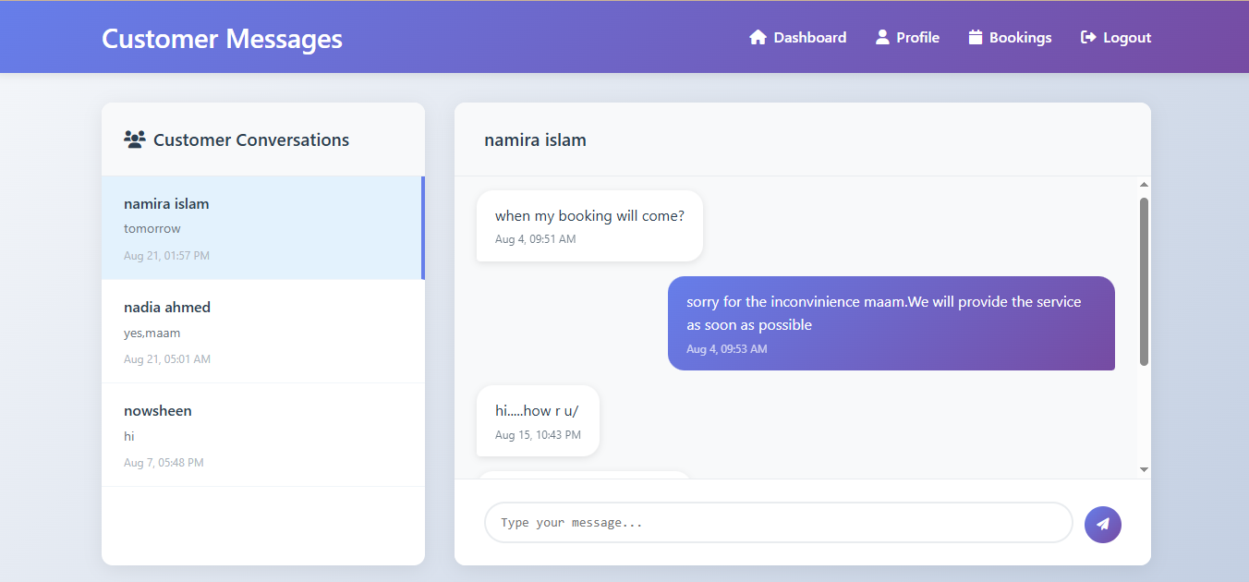

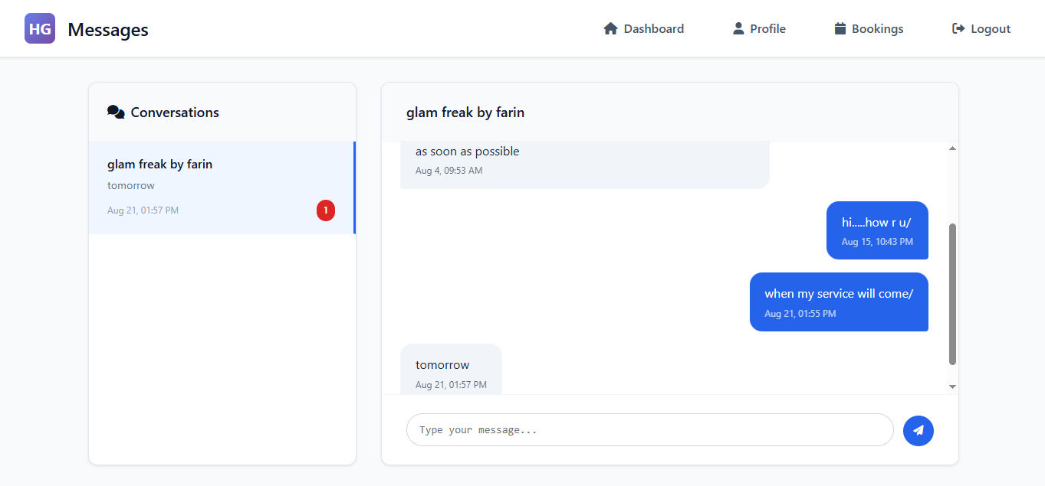

1.5 References

**Core Technologies:**

* PHP Official Documentation
* MySQL Documentation
* HTML5 and CSS3 W3C Standards
* JavaScript Documentation
* Font Awesome Icon Library

**Development Tools:**

* XAMPP/LAMP Server Environment
* Visual Studio Code Documentation

**Security Standards:**

* OWASP Web Application Security Guidelines
* PHP Session Management Best Practices

**Design Standards:**

* Responsive Web Design Principles
* Web Accessibility Guidelines (WCAG 2.1)

**2. Overall Description**

2.1 Product Perspective

HomeGlam is a standalone web-based platform that operates as an independent system connecting beauty service providers with customers in Dhaka. The system functions as a two-sided marketplace with separate interfaces for customers and parlour owners, integrated through a shared database and messaging system.

2.2 Product Features

**Core Features:**

* User registration and authentication (customers and parlour owners)
* Service booking and scheduling management
* Real-time messaging between customers and parlours
* Review and rating system

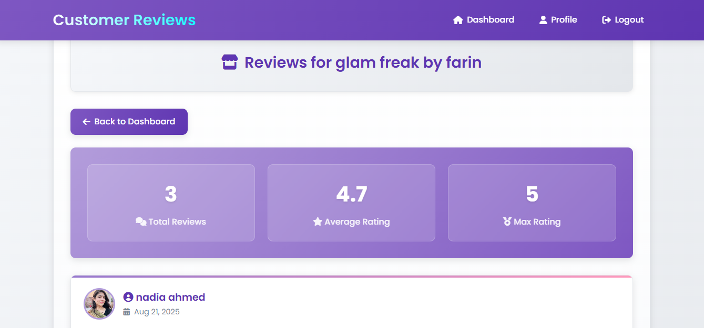

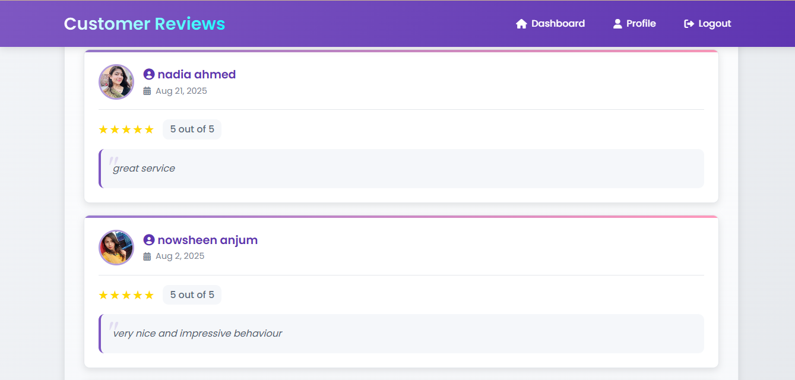

* Favorites and wishlist functionality

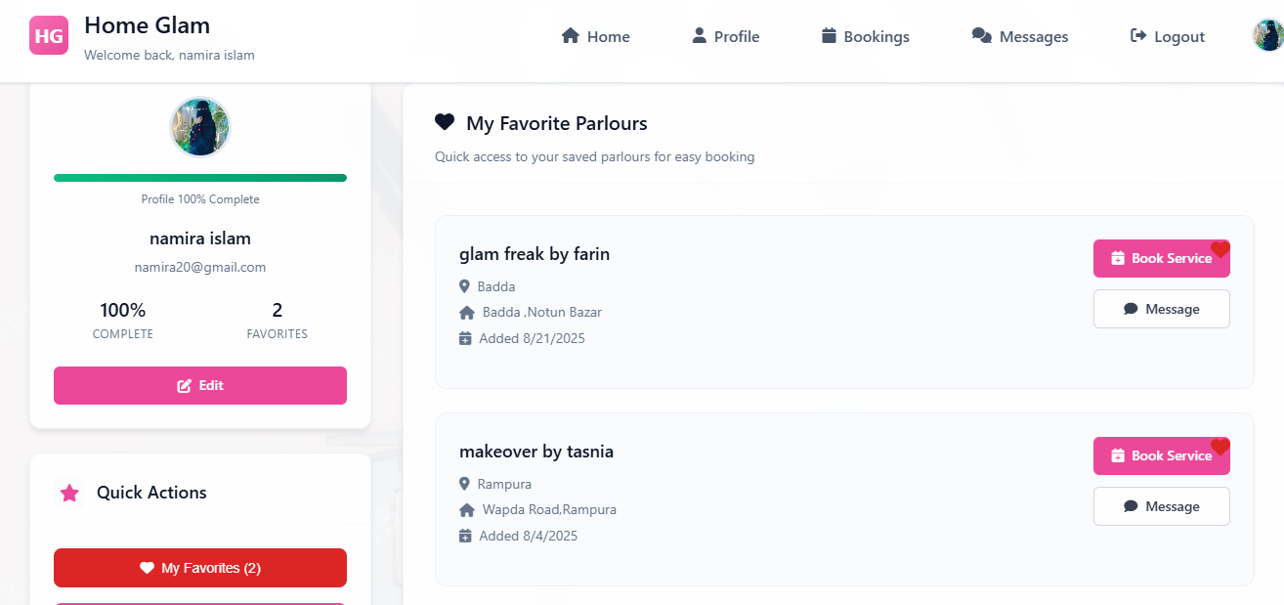

* Combo offer creation and management

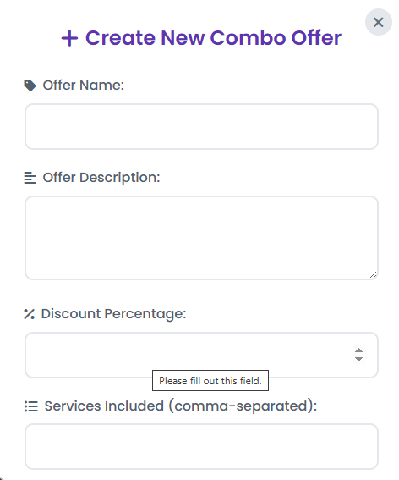

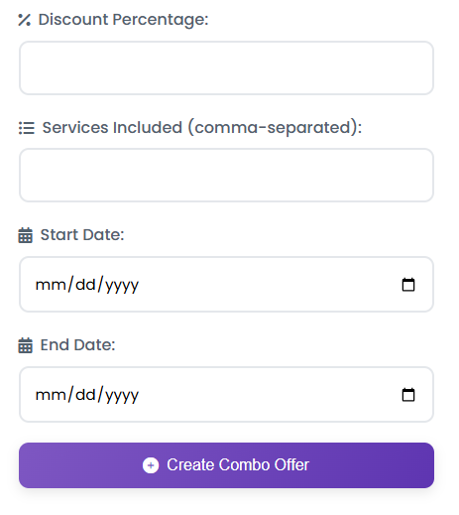

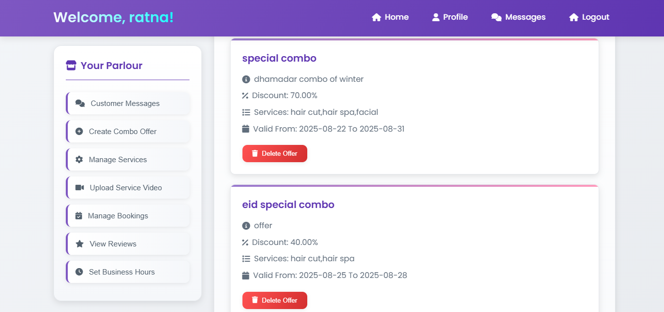

* Service video gallery

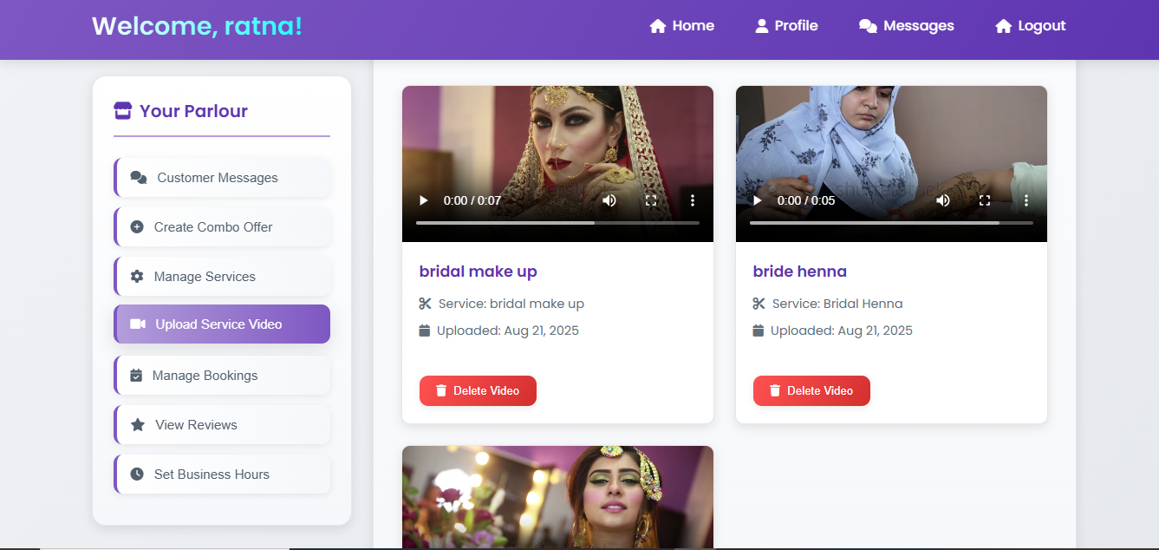

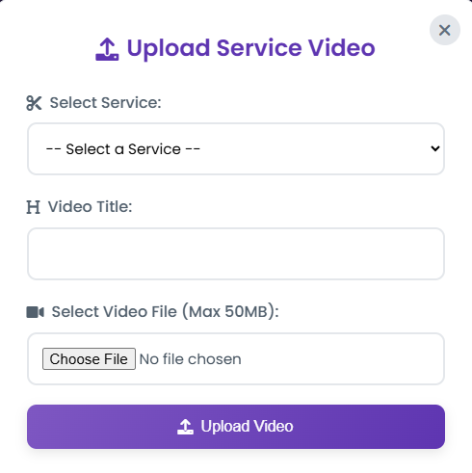

* Profile management with completion tracking
* Business hours configuration

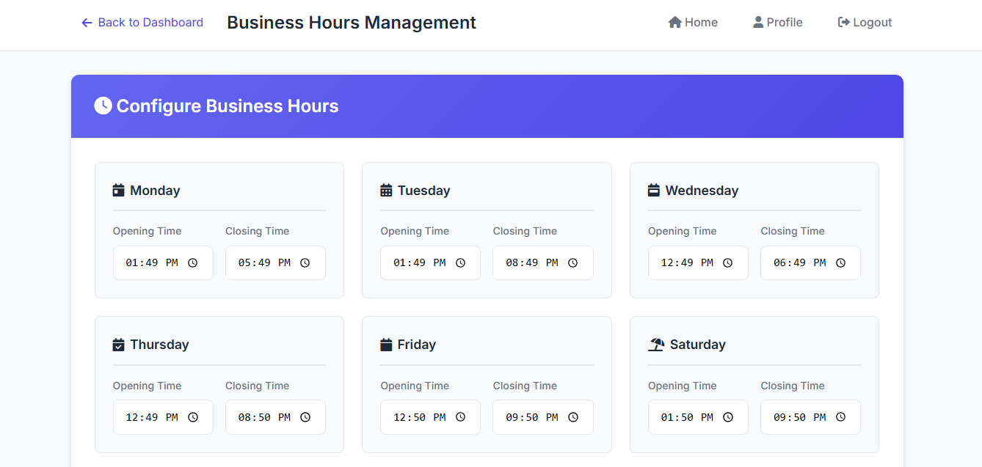

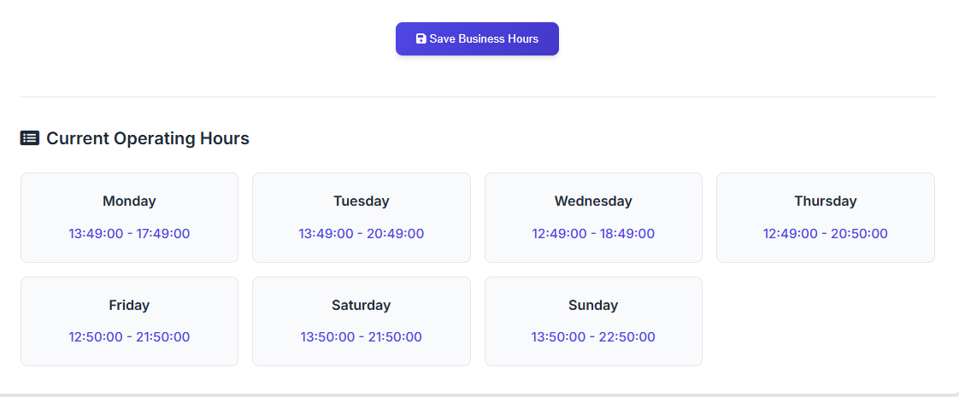

* Notification system

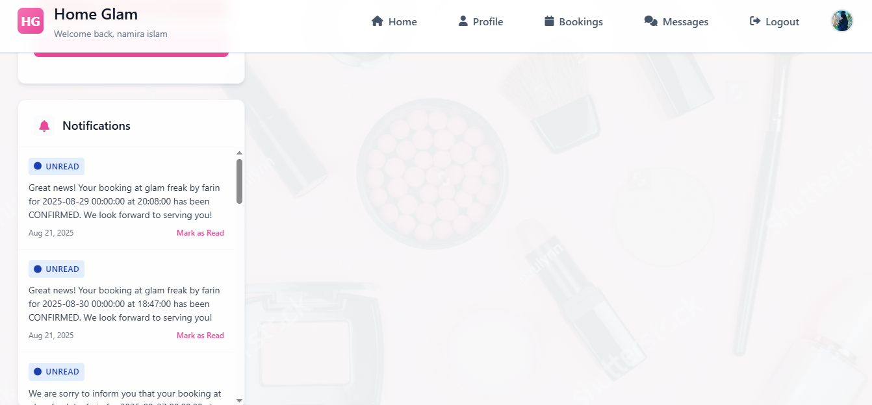

2.3 User Classes and Characteristics

**Primary Users:**

**Customers (Women in Dhaka):**

* Seek convenient home-based beauty services
* Need easy booking and communication tools
* Value reviews and ratings for decision-making
* Require profile management and service history tracking

**Parlour Owners:**

* Small business operators offering home services
* Need customer management and booking tools
* Require marketing features (videos, combo offers)
* Need communication channels with customers

2.4 Operating Environment

**Server Environment:**

* Web server with PHP 7.4+ support
* MySQL 5.7+ database server
* Apache/Nginx web server
* Linux/Windows server operating system

**Client Environment:**

* Modern web browsers (Chrome, Firefox, Safari, Edge)
* Internet connection (minimum broadband)
* Desktop, tablet, and mobile device compatibility
* Screen resolution: 320px minimum width for mobile responsiveness

**Development Environment:**

* XAMPP/LAMP local development stack

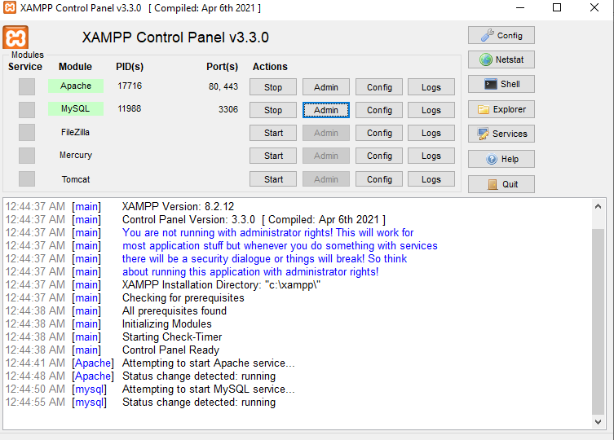

* PHP development tools

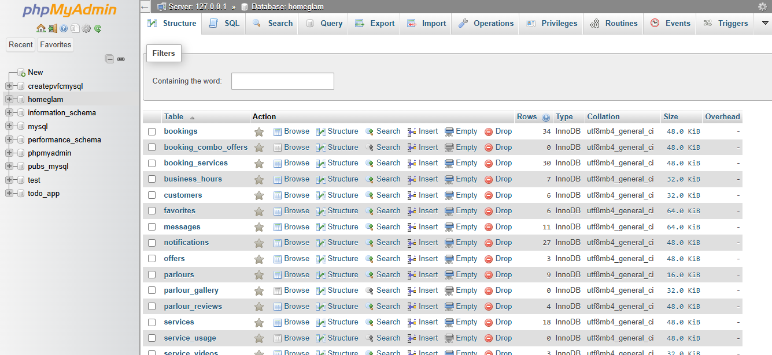

* MySQL database management tools

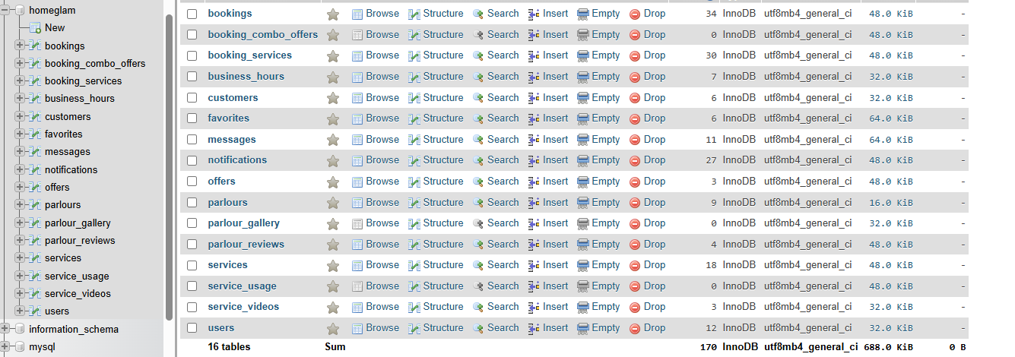

2.5 Design and Implementation Constraints

**Technical Constraints:**

* Maximum video file size limited to 50MB for service uploads
* Database queries must use prepared statements to prevent SQL injection
* Session-based authentication without external OAuth integration
* File upload restrictions to specific video formats (MP4, MOV, AVI, WMV, WEBM)
* Browser compatibility requirements for ES6+ JavaScript features

**Business Constraints:**

* Service area limited to Dhaka city only

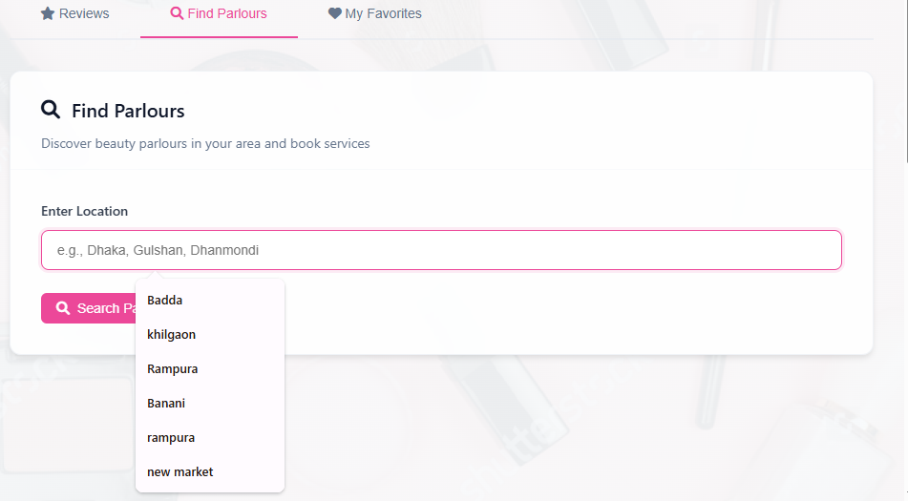

* Target market restricted to women customers
* Home-based service model only (no salon locations)

**Security Constraints:**

* HTTPS requirement for production deployment
* User data protection compliance
* Secure file upload validation and storage

2.6 User Documentation

**Customer Documentation:**

* Quick start guide for account registration and profile setup
* Step-by-step booking tutorial
* Messaging system user guide
* FAQ section for common queries

**Parlour Owner Documentation:**

* Business profile setup manual
* Service management guide
* Video upload tutorial
* Combo offer creation guide
* Booking management instructions

**Technical Documentation:**

* System installation guide
* Database schema documentation
* API endpoint reference (if applicable)

2.7 Assumptions and Dependencies

**Assumptions:**

* Users have basic internet literacy and smartphone/computer access
* Stable internet connection available to both customers and service providers
* Payment processing will be handled through external systems or cash-on-delivery
* Service providers have necessary licenses and certifications for beauty services
* Users will provide accurate location information within Dhaka

**Dependencies:**

* Web hosting service with PHP and MySQL support
* Domain name registration and SSL certificate
* Third-party services for email notifications
* Mobile network infrastructure in Dhaka for communication
* Local regulations compliance for home-based business operations

**3. System Features**

## **3.1 User Authentication System**

**Priority: High** - Essential for system access control. **Functional Requirements:**

* FR-1.1: Authenticate users with email/password

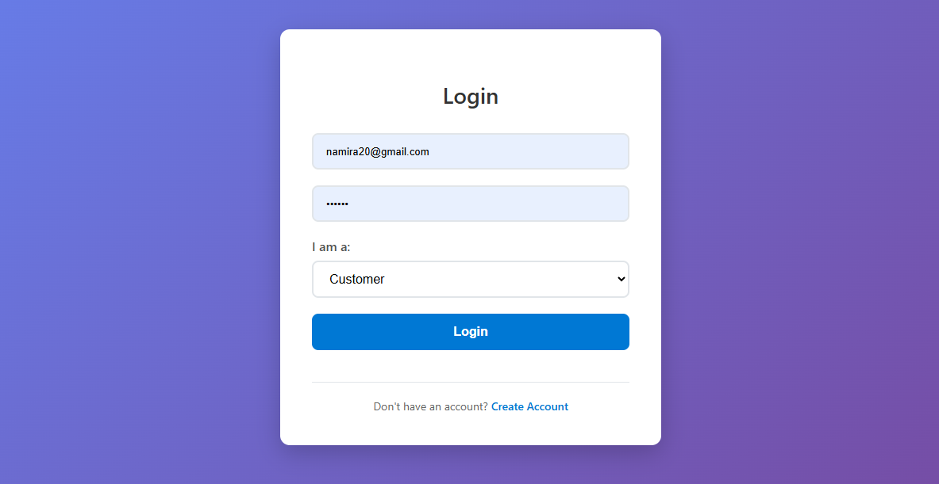

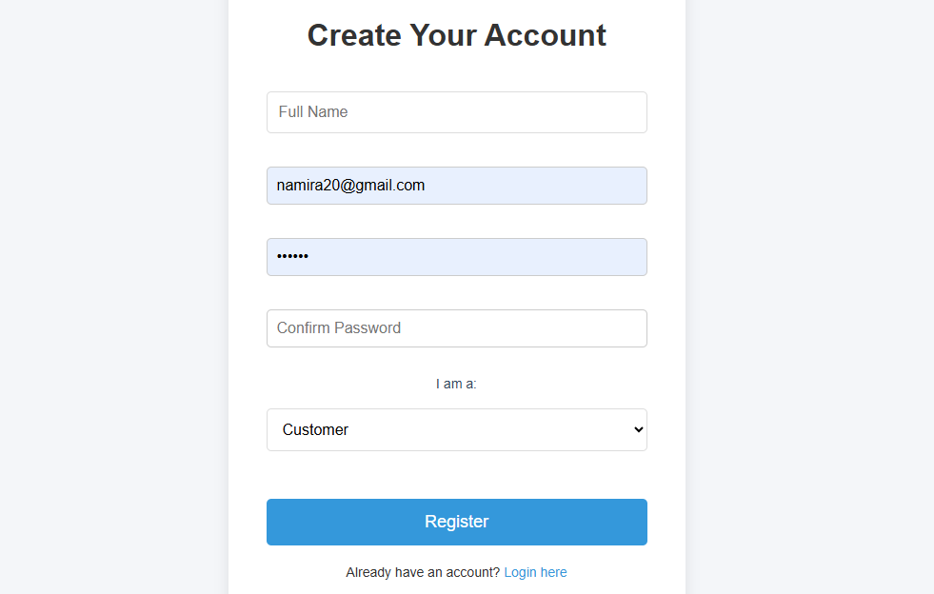

* FR-1.2: Support customer and parlour owner roles

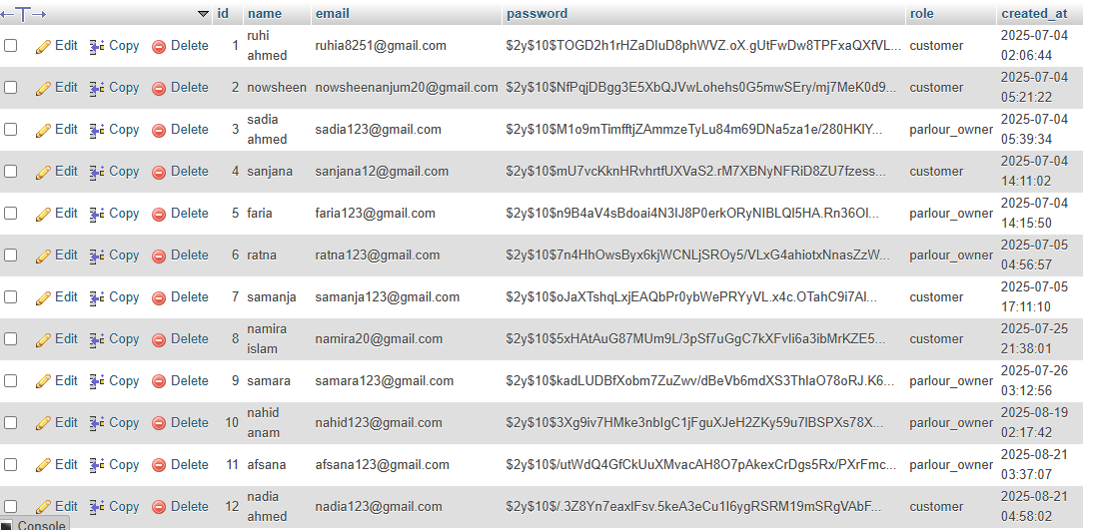

* FR-1.3: Maintain secure PHP sessions
* FR-1.4: Redirect unauthorized users to login

## **3.2 Service Booking Management**

**Priority: High** - Core business functionality. **Functional Requirements:**

* FR-2.1: Allow customers to book services
* FR-2.2: Display booking management for parlour owners
* FR-2.3: Track booking status (pending, confirmed, completed)
* FR-2.4: Send booking notifications

## **3.3 Messaging System**

**Priority: High** - Customer-parlour communication. **Functional Requirements:**

* FR-3.1: Enable bidirectional messaging
* FR-3.2: Display unread message counts
* FR-3.3: Store message history with timestamps
* FR-3.4: Mark messages as read when accessed

## **3.4 Review and Rating System**

**Priority: Medium** - Quality assurance feature. **Functional Requirements:**

* FR-4.1: Allow one review per customer per parlour
* FR-4.2: Provide review search functionality
* FR-4.3: Display reviews chronologically
* FR-4.4: Prevent duplicate reviews

## **3.5 Profile Management**

**Priority: Medium** - User data management. **Functional Requirements:**

* FR-5.1: Track profile completion percentage
* FR-5.2: Support profile picture uploads
* FR-5.3: Display completion alerts
* FR-5.4: Separate customer and parlour profiles

## **3.6 Service Video Gallery**

**Priority: Low** - Marketing enhancement. **Functional Requirements:**

* FR-6.1: Restrict video uploads to 50MB
* FR-6.2: Support multiple video formats
* FR-6.3: Associate videos with services
* FR-6.4: Allow video deletion by owners

## **3.7 Combo Offer Management**

**Priority: Medium** - Promotional feature. **Functional Requirements:**

* FR-7.1: Validate offer date ranges
* FR-7.2: Track offer-booking relationships
* FR-7.3: Prevent deletion of active offers
* FR-7.4: Calculate discount percentages

**4. External Interface Requirements**

4.1 User Interfaces

**Web-based responsive interface:**

* CSS3/HTML5 design for desktop, tablet, mobile (min 320px width)
* Dashboard with sidebar navigation and main content areas
* Modal dialogs for forms and uploads
* Real-time messaging with notification badges

4.2 Hardware Interfaces

**Server: 2GB RAM, 50GB storage, broadband connection Client: Web browser capable device, 1GB RAM minimum**

## 4.3 Software Interfaces

* MySQL 5.7+ database with PHP MySQLi/PDO connections
* Apache/Nginx web server with PHP 7.4+
* SSL/TLS support for HTTPS
* Local file storage for uploads

## 4.4 Communications Interfaces

* HTTP/HTTPS protocol with SSL/TLS encryption
* JSON for AJAX, HTML forms for data submission
* Minimum 1 Mbps internet connection
* Session management via secure cookies

**5. Other Nonfunctional Requirements**

## **5.1 Performance Requirements**

* Page load time: Maximum 3 seconds on broadband connection
* Database query response: Under 1 second for standard operations
* Video upload processing: Maximum 2 minutes for 50MB files
* Concurrent users: Support minimum 100 simultaneous sessions
* System availability: 99% uptime during business hours

## **5.2 Safety Requirements**

* Automatic database backup every 24 hours
* Session timeout after 30 minutes of inactivity
* File upload validation to prevent malicious content
* Error logging and monitoring for system failures
* Graceful degradation when services are unavailable

## **5.3 Security Requirements**

* Password encryption using secure hashing algorithms
* SQL injection prevention through prepared statements
* HTTPS encryption for all data transmission
* File upload restrictions and validation
* User input sanitization and validation
* Session management with secure cookies
* Access control based on user roles

## **5.4 Software Quality Attributes**

**Usability:**

* Intuitive navigation with consistent UI patterns
* Mobile-responsive design for all screen sizes
* Clear error messages and user feedback

**Maintainability:**

* Modular PHP code structure
* Consistent naming conventions
* Comprehensive code documentation

**Portability:**

* Cross-browser compatibility (Chrome, Firefox, Safari, Edge)
* Standard web technologies (HTML5, CSS3, JavaScript)
* MySQL database compatibility across platforms

**Reliability:**

* Error handling for database connection failures
* Input validation to prevent system crashes
* Backup and recovery procedures

**6. Other Requirements**

## **6.1 Regulatory Requirements**

* Bangladesh business registration compliance for home services
* Local data protection law adherence
* Age verification: 18+ for providers, 16+ for customers

## **6.2 Localization Requirements**

* Bengali language support
* Bangladeshi Taka (BDT) currency display
* Dhaka area address validation
* Bangladesh Standard Time (UTC+6)

## **6.3 Business Constraints**

* Service area limited to Dhaka only
* Women-only customer base
* Home-based services exclusively

## **6.4 Legal Requirements**

* Terms of service and privacy policy
* User data consent mechanisms
* Platform liability limitations

## **6.5 Technical Requirements**

* Mobile data usage optimization
* Database backup and migration tools
* Version control for system updates

**Appendices**

**A. Glossary**

* **Combo Offer:** Bundled service packages with discount pricing for multiple beauty treatments.
* **Home Glam:** Web platform connecting women customers with home-based beauty parlour services in Dhaka.
* **Parlour Owner:** Licensed beauty service provider offering treatments at customer's home.
* **Profile Completion:** Percentage tracker showing how much user profile information has been filled (20% per field).
* **Service Video:** Promotional videos uploaded by parlour owners to showcase their beauty services.

**B. Analysis Models**

* **Use case diagrams:** Customer and Parlour Owner interactions with login, booking, messaging, and profile management systems.
* **Database schema:** Entity relationships between Users, Parlours, Services, Bookings, Messages, Reviews, and Favorites tables.
* **System architecture:** Three-tier web architecture with presentation layer (HTML/CSS/JS), business logic (PHP), and data layer (MySQL).

**C. Issues List**

* **Pending:** Payment gateway integration method not specified in current requirements.
* **Pending:** Real-time messaging implementation approach needs clarification.
* **Pending:** Video storage backup and scalability strategy undefined.
* **Resolved:** File upload restrictions established (50MB video limit, specific format support).
* **Resolved:** User authentication and role separation clearly defined.